Christmas Communion
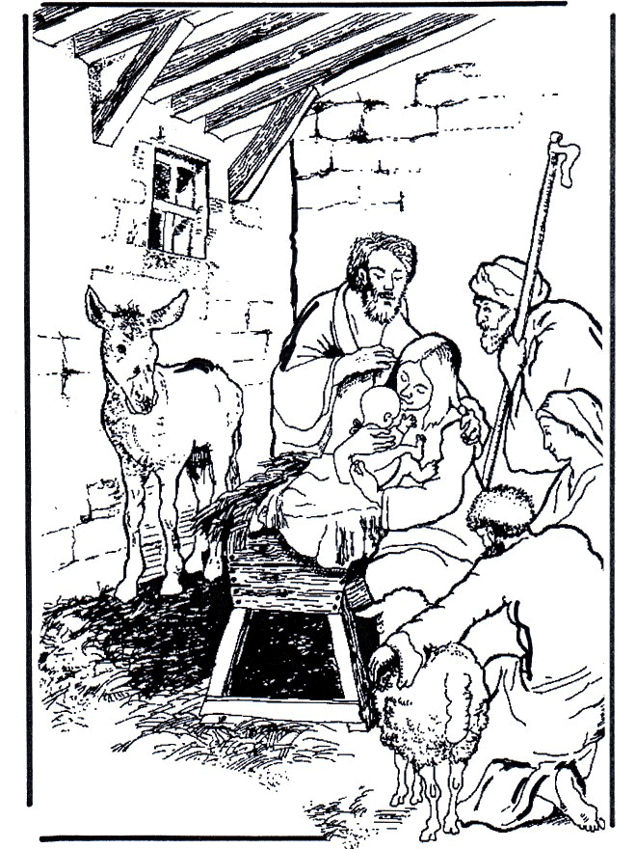

MUSIC
WELCOME
We come to remember the birth of our Saviour Jesus Christ we meet in His name and we share in His peace. The Prince of all Peace, Wonderful Counsellor, Almighty God. Amen
GATHERING
We bring this year that is nearly at a close with all our loss and sadness’s
The hopes and fears of all the years are met in thee
We bring to you our hopes and dreams for the future in the Benefice of Reepham and Wensum Valley Team Churches for each parish and each person living here.
The hopes and fears of all the years are met in thee
We bring the whole world to you asking for your Kingdom to be born afresh in us tonight Emmanuel God with us Come
The hopes and fears of all the years are met in thee
INVITATION TO CONFESSION
As we kneel with the shepherds before the new-born Christ child, we open our hearts with sorrow and faith;
You Lord were born for our salvation
Lord, have mercy. Lord have mercy

You came as Saviour to bring wholeness and peace
Christ, have mercy.
Christ, have mercy.
You came to bring light into the darkness of our lives.
Lord, have mercy.
Lord, have mercy.
May Almighty God, who sent his Son into the world to save sinners, bring you his grace and peace, now and for ever. Amen.
SONG OF THE ANGELS
Glory in the highest to the God of heaven!
Peace to all people on Earth X3
COLLECT
Lord Jesus Christ your birth at Bethlehem draws us to kneel in wonder at heaven touching earth accept our heartfelt praise
as we worship you our Saviour and our eternal God. Amen
LITURGY OF THE WORD
1st reading This is the word of the Lord. Thanks be to God.
MUSIC
GOSPEL ACCLAMATION
Alleluia, alleluia, alleluia The Word became flesh-
and dwelt among us, and we have seen his glory. Alleluia, Alleluia, Alleluia
Gospel Reading
Hear the Gospel of our Lord Jesus Christ according to N. Glory to you, O Lord.
At the end: This is the Gospel of the Lord. Praise to you, O Christ. Alleluia, Alleluia, Alleluia.
HOMILY
Please Stand
CREED Let us affirm our common faith in Jesus Christ.
Do you believe and trust in God the Father,
source of all being and life, the one for whom we exist? I believe and trust in him.
Do you believe and trust in God the Son,
who took our human nature, died for us and rose again? I believe and trust in him.
Do you believe and trust in God the Holy Spirit who gives life to the people of God and makes Christ known in the world? I believe and trust in him.
This is the faith of the Church. This is our faith.
We believe and trust in one God, Father, Son and Holy Spirit.
PRAYERS
Response to prayers is The hopes and fears of all the years are met in thee
PEACE
Unto us a child is born, unto us a son is given and his name is called the Prince of Peace.
The peace of the Lord be always with you
And also with you.
Let us offer one another a sign of peace.
MUSIC
PREPARATION OF THE TABLE
Word made flesh; life of the world, in your incarnation you embraced our poverty: by your Spirit we share in your riches. Amen
EUCHARISTIC PRAYER
The Lord be with you. And also with you.
Lift up your hearts We lift them to the Lord.
Let us give thanks to the Lord our God. It is right to give thanks and praise.
All glory and honour be yours always and everywhere,
Mighty Creator, Ever-living God. We give you thanks and praise for your Son, our Saviour Jesus Christ, who for love of all humanity humbled himself, was born of the Virgin Mary by the power of your Spirit,
and lived as one of us. In this mystery of the Word made flesh
you have caused his light to shine in our hearts, to give knowledge of your glory in the face of Jesus Christ. In him we see our God made visible and so are caught up in the love of the God.
Therefore with all the angels of heaven
we lift our voices to proclaim the glory of your name
and sing our joyful hymn of praise:
Holy, holy, holy Lord,
God of power and might, heaven and earth are full of your glory.
Hosanna in the highest.
Blessed is he who comes in the name of the Lord.
Hosanna in the highest.
Lord, you are holy indeed, the source of all holiness;
grant that by the power of your Holy Spirit, and according to your holy will, these gifts of bread and wine may be to us the body and blood of our Lord
Jesus Christ: who, in the same night that he was betrayed, took bread and gave you thanks; he broke it and gave it to his disciples, saying: Take, eat; this is my body which is given for you. do this in remembrance of me. In the same way, after supper he took the cup and gave you thanks; he gave it to them, saying: Drink this, all of you;
this is my blood of the new covenant,
which is shed for you and for many for the forgiveness of sins.
Do this, as often as you drink it,
in remembrance of me.
Christ is the bread of life. When we eat this bread and drink this cup,
we proclaim your death, Lord Jesus, until you come in glory.
We celebrate this memorial of our redemption. As we offer you this our sacrifice of praise and thanksgiving,
we bring before you this bread and this cup and we thank you for counting us worthy
to stand in your presence and serve you.
And so, Father, calling to mind his death on the cross,
his perfect sacrifice made once for the sins of the whole world; rejoicing in his mighty resurrection and glorious ascension, and looking for his coming in glory, Send the Holy Spirit on your people and gather into one in your kingdom
all who share this one bread and one cup, so that we, in the company of Mary and all the saints, may praise and glorify you for ever, through Jesus Christ our Lord; by whom, and with whom, and in whom,
in the unity of the Holy Spirit,
all honour and glory be yours, Almighty Father, for ever and ever. Amen.
SHARING COMMUNION Let us pray with confidence as our Saviour has taught us Our Father in heaven, hallowed be your name, your kingdom come, your will be done, on earth as in heaven. Give us today our daily bread, forgive us our sins
as we forgive those who sin against us. Lead us not into temptation but deliver us from evil. For the kingdom, the power, and the glory are yours now and for ever. Amen.
We break this bread to share in the Body of Christ.
Though we are many we are one body because we all share in one Bread.
Lamb of God, You take away the sin of the world Have mercy on us Lamb of God, You take away the sin of the world Have mercy on us Lamb of God, you take away the sin of the world Grant us peace.
Draw near with faith.
Receive the body of our Lord Jesus Christ which he gave for you,
and his blood which he shed for you.
Eat and drink in remembrance that he died for you, and feed on him in your hearts by faith with thanksgiving. Amen
MUSIC
POST COMMUNION PRAYER God our Father,
Whose Word has come among us In the Holy Child of Bethlehem: May the light of faith illumine our hearts and shine in our words and deeds; Through him who is Christ the Lord. Amen
Almighty God, we thank you for feeding us with the body and blood of your Son Jesus Christ. Through him we offer you our souls and bodies
to be a living sacrifice. Send us out in the power of your Spirit to live and work to your praise and glory. Amen.

BLESSING Christ, who by his incarnation gathered into one
things earthly and heavenly,
fill you with peace and goodwill and make you partakers of the di- vine nature; and the blessing of God almighty, the Father, the Son, and the Holy Spirit, be among you and remain with you always. Amen
Go in peace to love and serve the Lord.
In the name of Christ. Amen.

